Mini Project Report on
STOCK MARKET PRICE PREDICTION
Submitted in partial fulfillment of the requirement for the award of the degree of

BACHELOR OF TECHNOLOGY

IN

COMPUTER SCIENCE & ENGINEERING

Submitted by: University Roll no.
Priyanshi Mathur 2021966

Under the Mentorship of

Mr. Kireet Joshi
Assistant Professor



Department of Computer Science and Engineering
Graphic Era (Deemed to be University)
Dehradun, Uttarakhand
July-2024



CANDIDATE’S DECLARATION

I hereby certify that the work which is being presented in the project report entitled “Stock Market Price Prediction Using Machine Learning” in partial fulfillment of the requirements for the award of the Degree of Bachelor of Technology in Computer Science and Engineering of the Graphic Era (Deemed to be University), Dehradun shall be carried out by the under the mentorship of Mr. Kireet Joshi, Assistant Professor, Department of Computer Science and Engineering, Graphic Era (Deemed to be University), Dehradun.

Name: Priyanshi Mathur
University Roll no.: 2021966

Table of Contents

Chapter No. | Description | Page No.
Chapter 1 | Introduction
Chapter 2 | Literature Survey
Chapter 3 | Methodology
Chapter 4 | Result and Discussion
Chapter 5 | Conclusion and Future Work
 | References

Chapter 1
Introduction
  - Introduction:

It begins with an introduction to existing stock prediction methods like fundamental and technical analysis. The proposed system would use machine learning models to analyze historical stock price data and sentiment analysis of news articles to predict future stock prices, volatility, and market trends.
A market where shares are publicly issued and traded is known as share market. Implementing the concept of algorithmic trading, which uses automated, preprogrammed trading strategies to predict stock prices. Time series forecasting (predicting future values based on historical values) applies well to stock forecasting.
Demand of Stock have become huge with Increased in popularity of Stock in Digital world. Prediction and Analysing stock can benefit People to think before buying or selling stocks. So, A New Stock Price Prediction through Deep Learning Algorithms has been analysed and visualized. Through This System we can predict of any Company stock in the world.

  - Problem statement:

The objective of the stock market price prediction project is to develop a sophisticated model capable of accurately forecasting the future prices of various stocks. Leveraging historical price data, market trends, and other relevant financial indicators, the project aims to utilize advanced machine learning algorithms to identify patterns and predict price movements. This predictive capability is intended to provide investors and financial analysts with actionable insights, thereby enhancing decision-making processes, optimizing portfolio management, and potentially increasing returns while managing risk. The project will also address challenges such as market volatility, data noise, and the dynamic nature of financial markets.
It begins with an introduction to existing stock prediction methods like fundamental and technical analysis

  - Need of Project:

The stock market is known for being volatile, dynamic, & nonlinear.
Accurate stock market prediction is extremely challenging because of multiple factors.
But, all of this also means that there’s a lot of data to find patterns in.
So, we keep exploring analytics techniques to detect stock market trends.
So, they can be analyzed as a sequence of discrete- time data.
Despite the volatility, stock prices aren’t just randomly generated numbers.

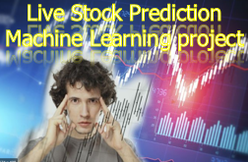

Chapter 2
Literature Survey
2.1 Literature Survey

Stock market price prediction using machine learning has gained significant attention in recent years due to its potential for high financial returns and the advancement of predictive algorithms. A variety of approaches have been explored, including time series analysis, neural networks, and ensemble methods. Traditional time series models like ARIMA have been augmented by more sophisticated techniques such as Long Short-Term Memory (LSTM) networks and other deep learning models, which capture temporal dependencies and complex patterns in stock data. Ensemble methods, combining the predictions of multiple models, have also shown promise in improving accuracy. Feature selection, incorporating both technical indicators and external factors like news sentiment, is crucial for enhancing model performance. Despite the progress, challenges remain in handling market volatility and the non-stationary nature of financial data. Continuous research aims to refine these models for better accuracy and robustness, leveraging advancements in computational power and data availability.
Enhancing Profit by Predicting Stock Prices using Deep Neural Networks, IEEE 2019-Soheila The prediction of economic time series is quite a herculean task, which has fascinated the attentiveness of many scholars and is extremely vital for investors. This paper focuses on presenting a deep learning system, which makes use of a range of facts for a part of the stocks on the NASDAQ exchange to predict the value of the stock. This model has been trained on the smallest of data for a particular stock and accurately estimates the concluding value of that stock for multi- step ahead. It consists of an auto encoder in order to remove noise and makes use of time series data engineering to syndicate the advanced features with the original features. These new features are given to a Stacked LSTM Auto encoder for multistep-ahead estimation of the stock concluding value. Further, this estimation is used by a profit maximization approach to offer assistance on the right time for buying and selling a particular stock. The results indicate that the suggested framework outclasses the state of the art time series forecasting methodologies with respect to analytical accuracy and effectiveness.

2.2 Abstract:

In today’s financial world stock exchange has become one of the most significant events. The world’s economy today is widely dependent on the stock market prices. The Stock Market has been very successful in attracting people from various backgrounds be it educational or business .The nonlinear nature of the Stock Market has made its research one of the most trending and crucial topics all around the world.. People decide to invest in the stock market on the basis of some prior research knowledge or some prediction. In terms of prediction people often look for tools or methods that would minimize their risks and maximize their profits and hence the stock price prediction takes on an influential role in the ever challenging stock market business. Adopting traditional methodologies such as fundamental and technical analysis doesn’t seem to ensure the consistency and accuracy in the prediction. As a result the machine learning technologies have become the recent trend in the stock market prediction whose prediction is based on the existing stock market values eventually as an outcome of training on their previous values. This paper focuses on RNN (Recurrent Neural Networks) and LSTM (Long Short term memory) technologies in predicting the ongoing trend of the stock market.
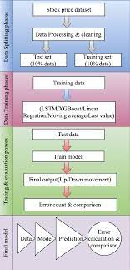

Chapter 3
Methodology
Stock market prediction seems like a complicated problem because there are various factors that are still left unaddressed and do not seem to be statistical at first. But to our rescue there are various machine learning algorithms by using which we could efficiently predict current trends in the stock market by using the references from the previous data. Here the dataset that we are going to use has been collected from Yahoo finance. This dataset consists of nearly 9,00,000 records related to the stock prices required and many other values that are relevant to each other. This data predicted the stock prices at some intervals of time for each day in a year. Many sections such as volume, date etc. were included in it. In order to simulate and analyze only one company’s data was taken into account. The data considered or taken into account was readily available in the csv format which was first read and converted into a data frame by making use of one of the most popular libraries, Pandas in Python. In the due course, one specific company’s data was pulled out by separating data depending on the symbol field. After this, the data was segregated into testing and training data sets by performing normalization by using yet another popular Python library known as S klearn library. The test set was placed as 20 percent of the dataset that was available. Although Machine learning has various algorithms that could be used for predicting the stock prices here in this paper we make use of two main algorithms known as RNN and LSTM.

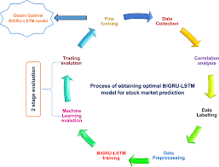
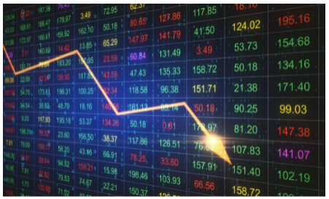

Recurrent Neural Network is a type of Neural Network in which the input to the next layer is taken from the output of the previous layer. It has many types to it and LSTM is one among them. LSTM stands for Long Short Term Memory. It basically has three parts to it which are input layer, forget layer, output layer. Input layer is responsible for deciding what amount of information should be carried forward to the next layer from the previous layer and the output layer is responsible for deciding what amount of data should be sent forward into the next layer as input. The reason for the immense popularity of the LSTM is its special power to memorize the data. In a basic neural network that consists of only one layer that is hidden the number of layers to be contained in the input layer mostly depends on the dimensionality of the data, and these input layer neurons get connected to the hidden layers via ‘synapses’. The relationship between each of the two nodes from the input layer to the hidden layer consists of a coefficient called weight which acts as a decision maker for the signals. The learning process of the model is basically nothing but a continuous fine-tuning of weights and gradually after the completion of the entire process, the artificial neural networks will have optimum weights for each synapse. An activation function such as a sigmoid or a tangent function is applied to the input layers in order to minimize the error rates and a soft max activation function is used in the output layer. The main functionality of this activation function is to produce non linearity in the model. After this a Back propagation algorithm will be applied in which the same process repeats itself again and again that is, the information keeps getting transferred back and forth until the weights are normalized and the error rate is minimalized. Finally the model will be trained on the training dataset and tested on the test data set.
Chapter 4
Result and Discussion:

Importing Data
Preprocess the data – Train and Test
Split the data into training/ test sets
Creating and Training the Model
Making Predictions and plot the output
Evaluating and Improving Predictions

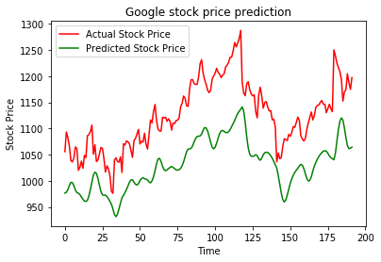

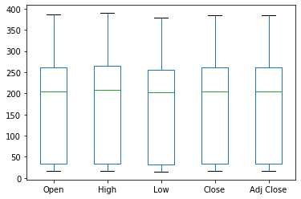

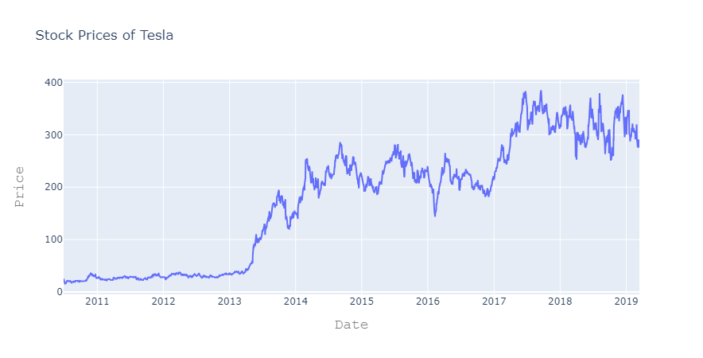

Chapter 5
Conclusion and Future Work:
5.1 Conclusion

From the research done so far it could be concluded that the RNN and LSTM libraries are very effective in determining the stock price trends effectively relative to the actual market trend. At the same time what we could find out is that the python libraries that were used as a part of the training process were not very optimal. As far as the training speed is considered the functions that we use from the mathematics principle have a lot faster speed comparatively and they consist of more detailed designs and significant improvements when tested under various situations. However, the python library functions are considered to be more adaptable. From our work done so far we can easily tell that certain stock trends can be predicted easily on the basis of certain general rules and regulations of the stock. This the main reason behind the existence of the private placement institutes. Few things such as optimization of the neural network parameters as well as the training process however always has much room for improvement. All these points would be considered as further steps in the research.

5.2 Future Work

Machine Learning and Data science is a game changer in this domain so there is a lot of data to find patterns in for predicting with high degree of accuracy.
In future we will try to predict the values based on multiple factors such as politics, global economic conditions, unexpected events like covid, companies financial performance, and so on.
Decided to implement a simple User Interface to operate this whole process for users so to make people engage in Stock market.

References:

Fischer, T., & Krauss, C. (2018). Deep learning with long short-term memory networks for financial market predictions. European Journal of Operational Research, 270(2), 654-669.
Patel, J., Shah, S., Thakkar, (2015). Predicting stock market index using fusion of machine learning techniques. Expert Systems with Applications, 42(4), 2162-2172.
Brownlee, J. (2018). Introduction to Time Series Forecasting with Python: How to Prepare Data and Develop Models to Predict the Future. Machine Learning Mastery.
Towards Data Science articles on stock market prediction using machine learning.
T say, R. S. (2010). Analysis of Financial Time Series.

